# Team Activity - Week 5

Objective: Practice SQL queries on the course database(s).

## Question 1

Team Leader: Saúl Abraham Arana Calderón

Question: Count how many works of art each artist has (show artist's name and quantity).

### SQL

USE v_art;

SELECT artist.fname First_Name, artist.lname Last_Name, COUNT(artwork.artwork_id) AS Total_Pictures

FROM artist

JOIN artwork ON artist.artist_id = artwork.artist_id

GROUP BY artist.artist_id;

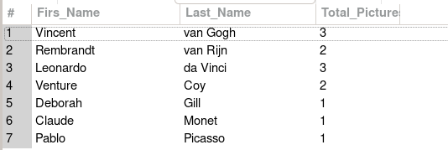

## Question 2

Team Leader: Saúl Abraham Arana Calderón

Question: List all works containing the keyword “landscape”.

### SQL

USE v_art;

SELECT artwork.title, keyword.keyword

FROM artwork

JOIN artwork_keyword ON artwork.artwork_id = artwork_keyword.artwork_id

JOIN keyword ON artwork_keyword.keyword_id = keyword.keyword_id

WHERE keyword.keyword = 'landscape';

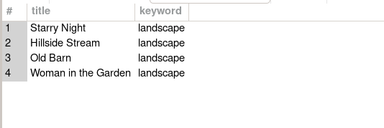

## Question 3

Team Leader: Saúl Abraham Arana Calderón

Question: Find the year of the oldest work for each artist's country.

### SQL

USE v_art;

SELECT artist.fname First_Name,artist.lname Last_Name, artist.country, MIN(artwork.artyear) AS Oldest_Picture

FROM artist

JOIN artwork ON artist.artist_id = artwork.artist_id

GROUP BY artist.country;

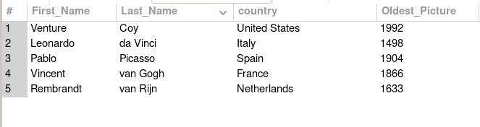

## Question 4

Team Leader: Saúl Abraham Arana Calderón

Question: Count how many orders each employee (staff) handled in 2017.

### SQL

USE bike;

SELECT co.staff_id ID, st.first_name First_Name, st.last_name Last_name, COUNT(co.cust_order_id) AS total_orders

FROM cust_order co

LEFT JOIN staff st

ON st.staff_id = co.staff_id

WHERE YEAR(order_date) = 2017

GROUP BY co.staff_id;

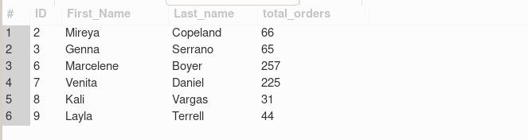

## Question 5

Team Leader: Saúl Abraham Arana Calderón

Question: Show orders with status “4” (completed) that required more than 5 days to ship.

### SQL

USE bike;

SELECT cust_order_id, order_date, shipped_date

FROM cust_order

WHERE order_status = 4

AND DATEDIFF(shipped_date, order_date) > 5;

